Experiment No. – 5
Date of Performance:
Date of Submission:
Program Execution/  formation/  correction/  ethical practices  (06) | Timely  Submission  (01) | Viva  (03) | Experiment  Total (10) | Sign with Date

Experiment No. 5
Python Libraries and Data Structure by using RNN or LSTM.

1.1 Aim: Implementation of Python Libraries and Data Structure by using RNN or LSTM.

1.2 Course Outcome: Implement Deep Learning techniques.

1.3 Learning Objectives: Develop real life applications using learning concepts.

1.4 Requirement:Python (Google Colab)

1.5 Related Theory:

RNN:
A recurrent neural network (RNN) is a type of artificial neural network which uses sequential data or time series data. These deep learning algorithms are commonly used for ordinal or temporal problems, such as language translation, natural language processing (nlp), speech recognition, and image captioning; they are incorporated into popular applications such as Siri, voice search, and Google Translate. RNNs are a powerful and robust type of neural network, and belong to the most promising algorithms in use because it is the only one with an internal memory. Like many other deep learning algorithms, recurrent neural networks are relatively old. They were initially created in the 1980’s, but only in recent years have we seen their true potential. An increase in computational power along with the massive amounts of data that we now have to work with, and the invention of long short-term memory (LSTM) in the 1990’s, has really brought RNNs to the foreground.

Architecture:
RNNs have the same input and output architecture as any other deep neural architecture. However, differences arise in the way information flows from input to output. Unlike Deep neural networks where we have different weight matrices for each Dense network in RNN, the weight across the network remains the same. It calculates hidden state Hi for every input Xi . By using the following formulas:
h= σ(UX + Wh-1 + B) Y
= O(Vh + C) Hence
Y = f (X, h , W, U, V, B, C)
Here S is the State matrix which has element si as the state of the network at timestep i The parameters in the network are W, U, V, c, b which are shared across timestep.

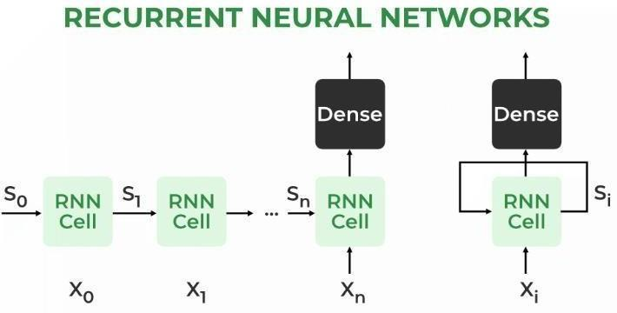

LSTM
LSTM networks are an extension of recurrent neural networks (RNNs) mainly introduced to handle situations where RNNs fail. Talking about RNN, it is a network that works on the present input by taking into consideration the previous output (feedback) and storing in its memory for a short period of time (short-term memory). Out of its various applications, the most popular ones are in the fields of speech processing, non-Markovian control, and music composition. It has been so designed that the vanishing gradient problem is almost completely removed, while the training model is left unaltered. Long time lags in certain problems are bridged using LSTMs where they also handle noise, distributed representations, and continuous values. With LSTMs, there is no need to keep a finite number of states from beforehand as required in the hidden Markov model (HMM). LSTMs provide us with a large range of parameters such as learning rates, and input and output biases. Hence, no need for fine adjustments. The complexity to update each weight is reduced to O(1) with LSTMs, similar to that of Back Propagation Through Time (BPTT), which is an advantage.

Architecture:
The basic difference between the architectures of RNNs and LSTMs is that the hidden layer
LSTM is a gated unit or gated cell. It consists of four layers that interact with one another in a way to produce the output of that cell along with the cell state. These two things are then passed onto the next hidden layer. Unlike RNNs which have got the only single neural net layer of tanh, LSTMs comprises three logistic sigmoid gates and one tanh layer. Gates have been introduced in order to limit the information that is passed through the cell. They determine which part of the information will be needed by the next cell and which part is to be discarded. The output is usually in the range of 0-1 where ‘0’ means ‘reject all’ and ‘1’ means ‘include all’. Hidden layers of LSTM.
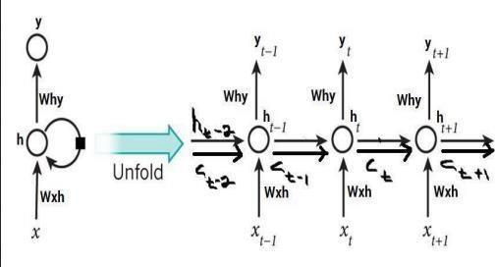
Advantages:
- An RNN remembers each and every piece of information through time. It is useful in time series prediction only because of the feature to remember previous inputs as well. This is called Long Short Term Memory.
- Recurrent neural networks are even used with convolutional layers to extend the effective pixel neighborhood.
- LSTM, they are much better at handling long-term dependencies. This is due to their ability to remember information for extended periods of time.
- LSTMs are much less susceptible to the vanishing gradient problem. This is because they use a different kind of activation function, known as an LSTM cell, which helps to preserve information over long sequences.
- LSTMs are very efficient at modeling complex sequential data. This is because they can learn high-level representations that capture the structure of the data.

Disadvantages:
- Gradient vanishing and exploding problems.
- Training an RNN is a very difficult task.
- LSTM are more complicated than traditional RNNs and require more training
data in order to learn effectively.
- LSTM are not well-suited for online learning tasks, such as prediction or
classification tasks where the input data is not a sequence. Third, LSTMs can be
slow to train on large datasets. This is due to the fact that they must learn the
parameters of the LSTM cells, which can be computationally intensive.

1.6 Procedure:
We will import our dataset with the help of pandas.Find out the last 5 rows of our datasets.We check for the data types, and also drop the irrelevant columns which are not required to train the model.
We will perform RNN and LSTM On given dataset.

1.7 Output:

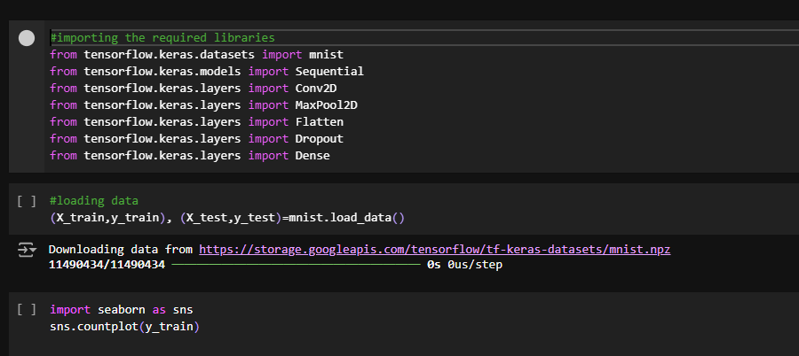

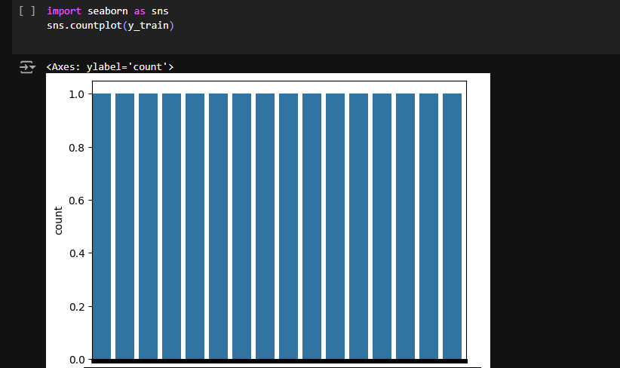

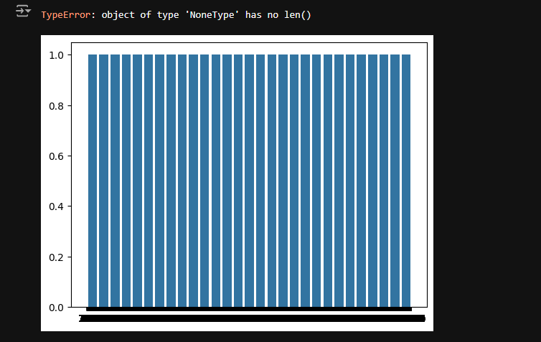

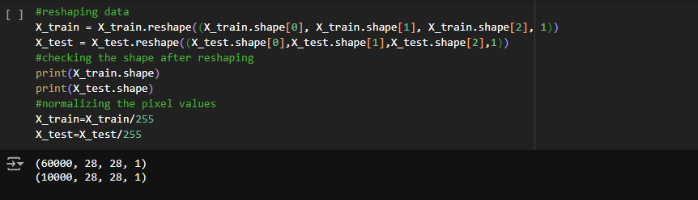

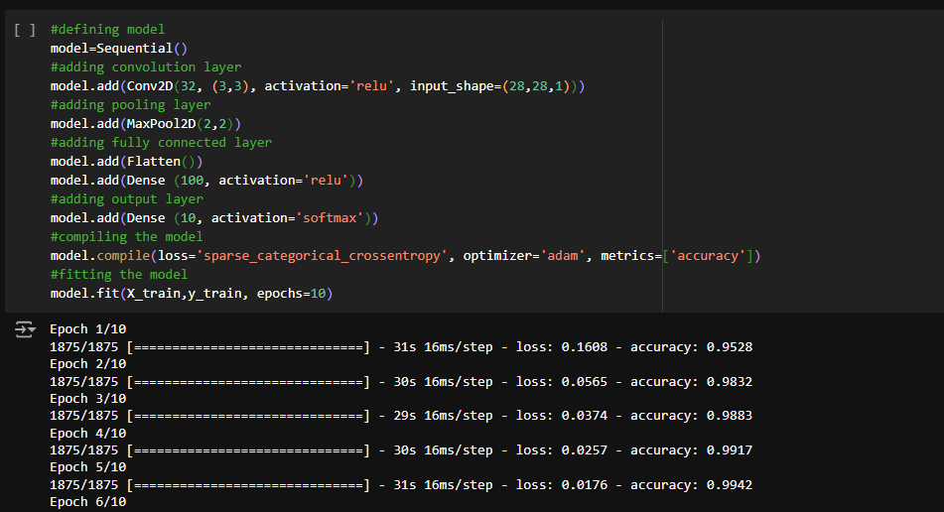
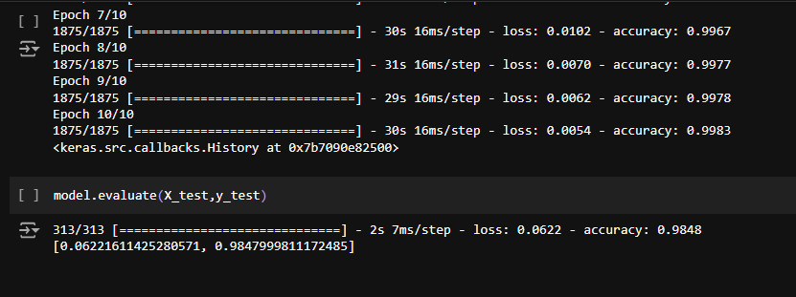

1.8 Conclusion:
In this experiment, we implemented both Recurrent Neural Networks (RNN) and Long Short-Term Memory (LSTM) networks using the Keras library in Python. RNNs are suitable for sequential data, but LSTMs offer a significant improvement by effectively handling long-term dependencies, overcoming the vanishing gradient problem of RNNs. We also demonstrated how to preprocess data, build models, and make predictions. These architectures are highly effective in applications like time series forecasting and natural language processing.

1.9 Questions:
1.Explain Deep Learning Concept.
Ans: Deep Learning is a specialized subset of machine learning that utilizes neural networks with multiple layers to model and understand complex patterns in data. Inspired by the human brain, it processes information through interconnected nodes (neurons) arranged in layers:

Key Concepts:
- Neural Networks: Composed of input, hidden, and output layers, where each layer transforms input data through mathematical functions.
- Activation Functions: Non-linear functions (e.g., ReLU, Sigmoid) that enable the network to learn complex relationships.
- Training Process: Involves forward propagation (input through the network), calculating error using a loss function, and backpropagation (adjusting weights to minimize error).
- Data and Computing Power: Requires large datasets and substantial computational resources (often using GPUs) for effective training.
Deep learning is widely used in:
- Image and Speech Recognition
- Natural Language Processing (NLP)
- Healthcare Analytics
- Autonomous Vehicles

2. Illustrate the RNN and LSTM with a Diagram.
Ans:
Recurrent Neural Network(RNN) is a type of Neural Network where the output from the previous step is fed as input to the current step. In traditional neural networks, all the inputs and outputs are independent of each other. Still, in cases when it is required to predict the next word of a sentence, the previous words are required and hence there is a need to remember the previous words. Thus RNN came into existence, which solved this issue with the help of a Hidden Layer. The main and most important feature of RNN is its Hidden state, which remembers some information about a sequence. The state is also referred to as Memory State since it remembers the previous input to the network. It uses the same parameters for each input as it performs the same task on all the inputs or hidden layers to produce the output. This reduces the complexity of parameters, unlike other neural networks.
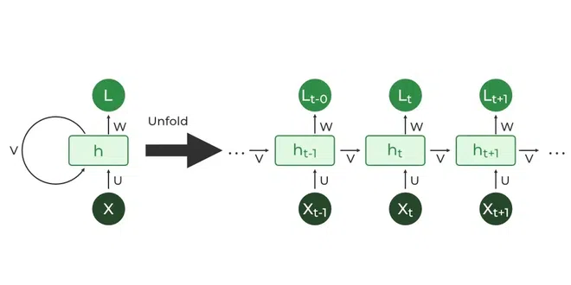

LSTM: The basic difference between the architectures of RNNs and LSTMs is that the hidden layer of LSTM is a gated unit or gated cell. It consists of four layers that interact with one another in a way to produce the output of that cell along with the cell state. These two things are then passed onto the next hidden layer. Unlike RNNs which have got only a single neural net layer of tanh, LSTMs comprise three logistic sigmoid gates and one tanh layer. Gates have been introduced in order to limit the information that is passed through the cell. They determine which part of the information will be needed by the next cell and which part is to be discarded. The output is usually in the range of 0-1 where ‘0’ means ‘reject all’ and ‘1’ means ‘include all’.
